SentinelTrapAI:
Autonomous AI Honeypot & Threat Logging Infrastructure Validation

Step 1: Workspace Directory Structure & File Architecture
The local workspace tree shows the organized layout of the backend files. The structure isolates core application code, including the main execution point (main.py), model schemas (models.py), database connect modules (db.py), data pipelines (seed_data.py), and isolated script sandbox dependencies (.venv).
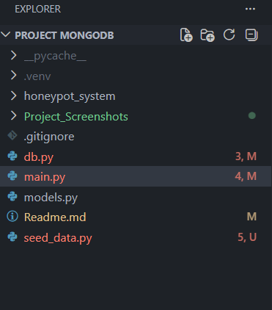
Figure 1: Workspace root directories showing backend files, virtual isolation, and asset stores.

Step 2: Database Initialization & Seeding Operations
Executing 'seed_data.py' clears old document conflicts and seeds clean entries into MongoDB. This run establishes a target test environment ('Simulation Lab') and creates an adversary node ('192.168.43.110') before testing out threat alarms like port scans, brute-forcing attempts, remote code executions (RCE), and log manipulation events.
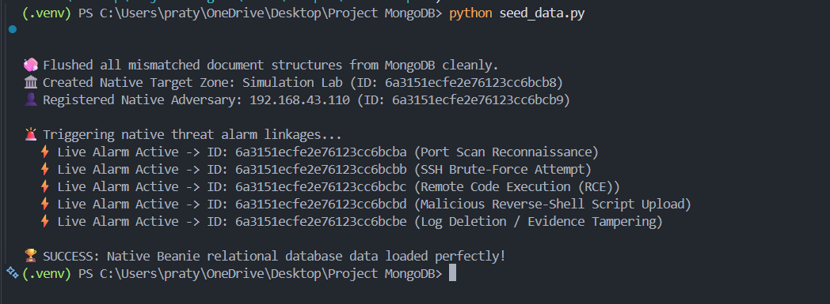
Figure 2: Data initialization script cleaning records and verifying test database entry linkages.

Step 3: FastAPI Interactive Server Documentation Interface
With the data layer seeded, running the local network server opens up the automated interactive documentation panel. Built on OpenAPI standards, it exposes real-time backend route definitions (endpoints like /departments/ and /alerts/) for headless diagnostics without needing a custom UI frontend layout.
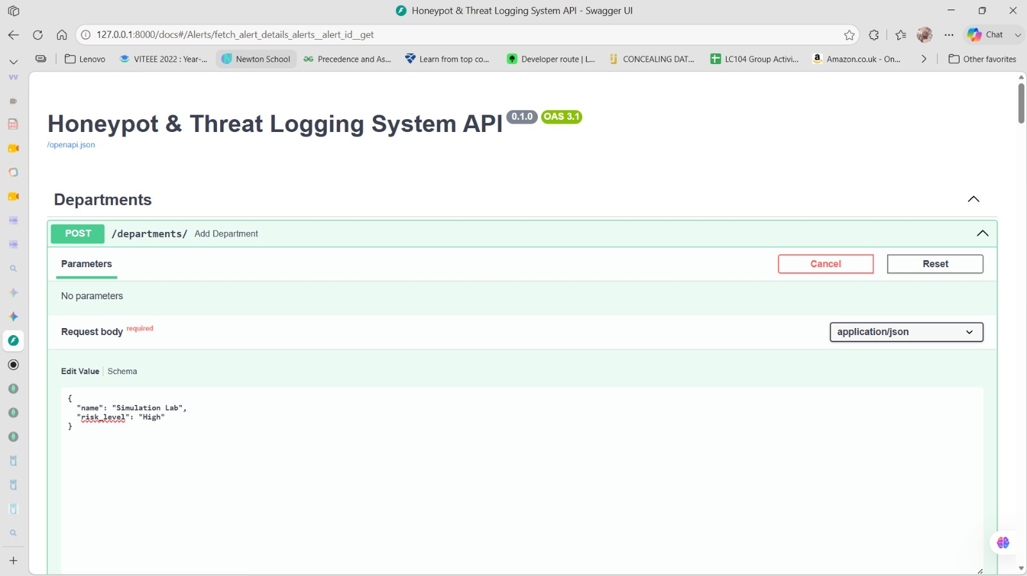
Figure 3: Interactive documentation dashboard providing test access points for live endpoint queries.

Step 4: Department Registration Verification Response
Testing out the department tracking endpoint shows a successful database record write. Sending a structured JSON request body adds the 'Simulation Lab' zone with an explicitly assigned 'High' risk threshold, safely returning a newly generated system hexadecimal ID object from the storage layer.
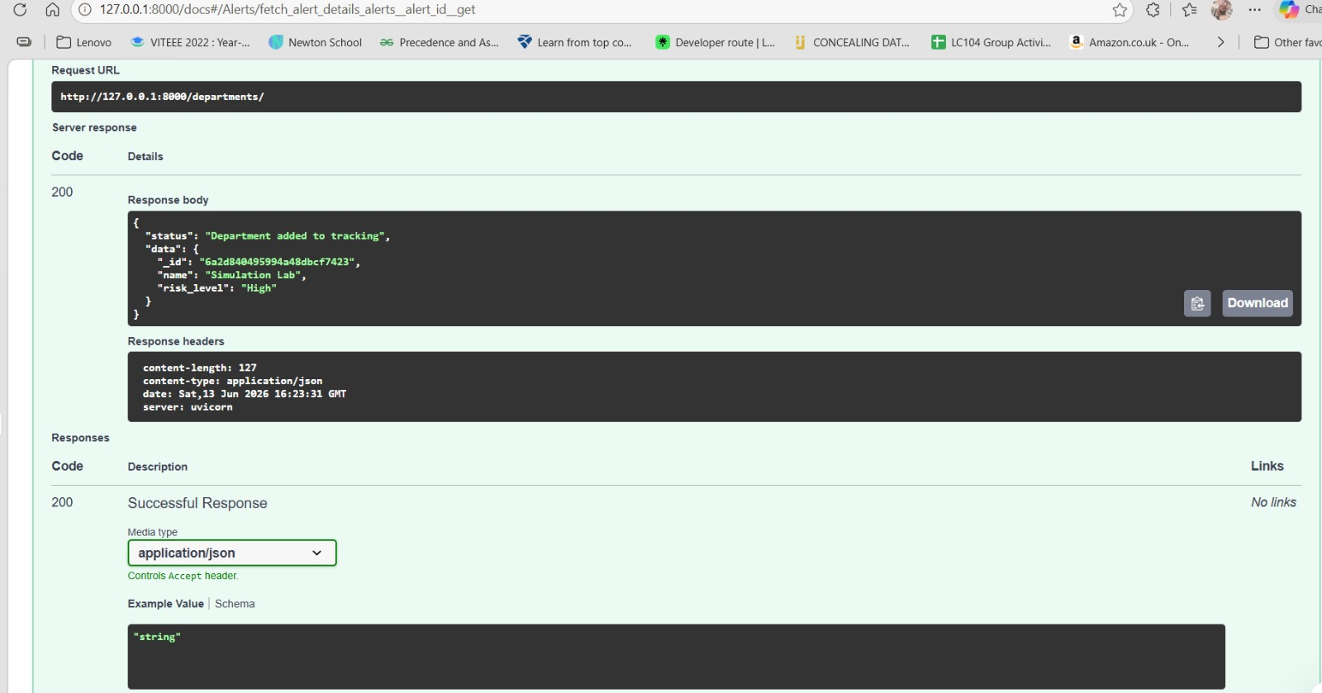
Figure 4: Response payload validating successful asset record creation inside the system database.

Step 5: Relational Threat Logging & Linked Document Mapping
This payload showcases the NoSQL document-referencing model at work. Instead of flattening information, the alert entry stores specialized cross-module object relationships. Here, a critical DDoS simulation event maps directly back to its designated target department ('Simulation Lab') and origin adversary profile via system database ID pointers.
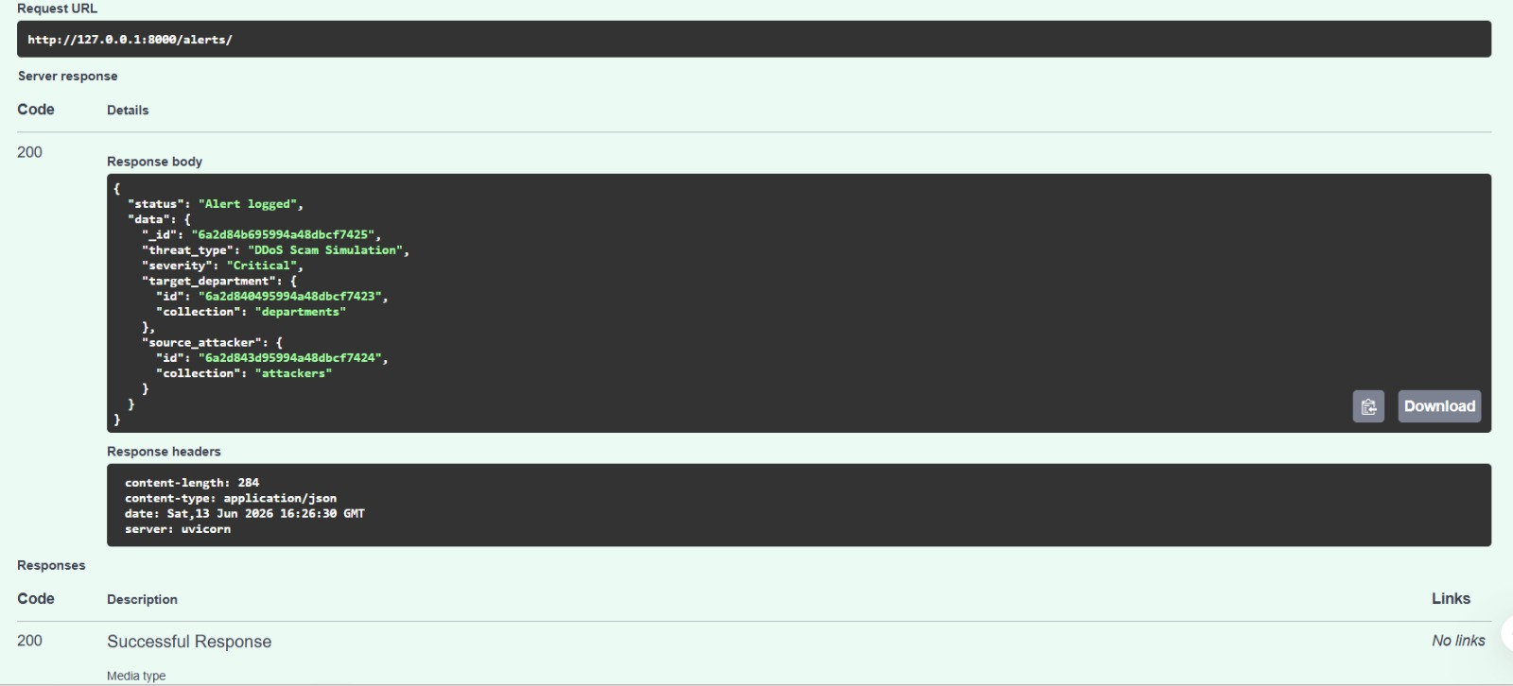
Figure 5: Normalized threat payload tracking deep-link mappings back to asset profiles.

Step 6: Real-Time Forensic Query Telemetry Validation
Querying a live connection event by its unique hash index pulls up comprehensive security data in real-time. This dynamic check confirms the backend correctly processes tracking variables, extracting matching values like threat severity, targeted location parameters, origin machine IP patterns, and source country locations ('India').
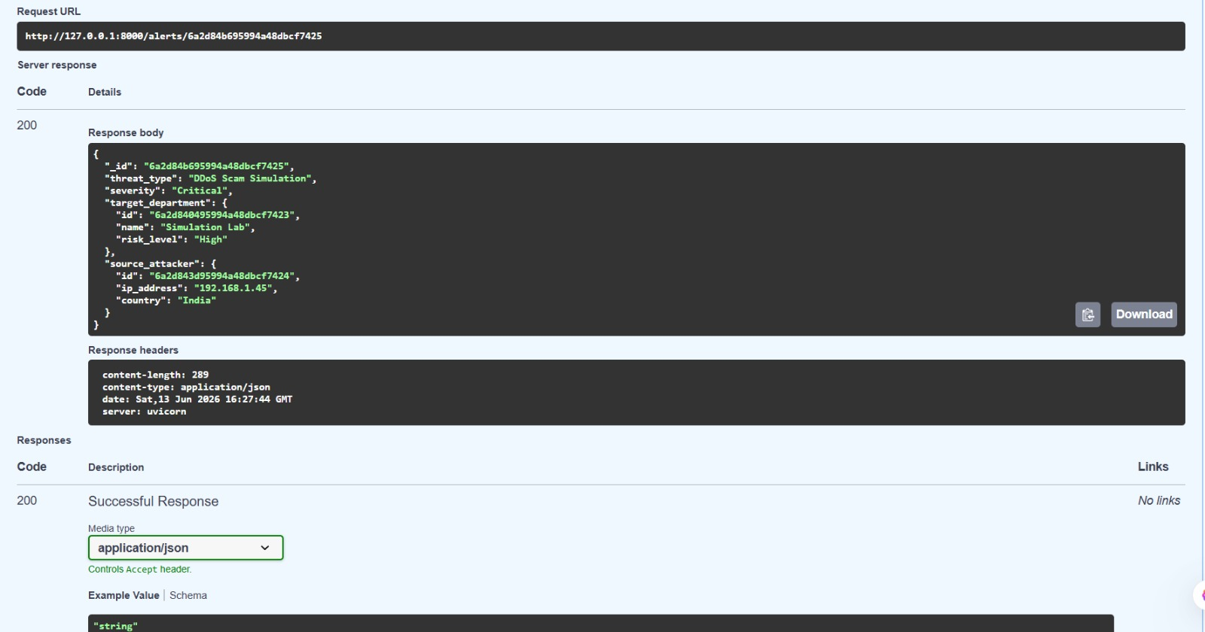
Figure 6: Detailed diagnostic query trace mapping out attacker parameters and alert history.

Step 7: Real-Time Threat Event Telemetry Tracking
This trace log captures historical transaction traffic. It documents clean department generation entries, test payload validations, and maps out targeted attacks. It also records common interface warnings like missing client icons (404 errors) or improperly typed network test data structures (422 Unprocessable Entity errors).
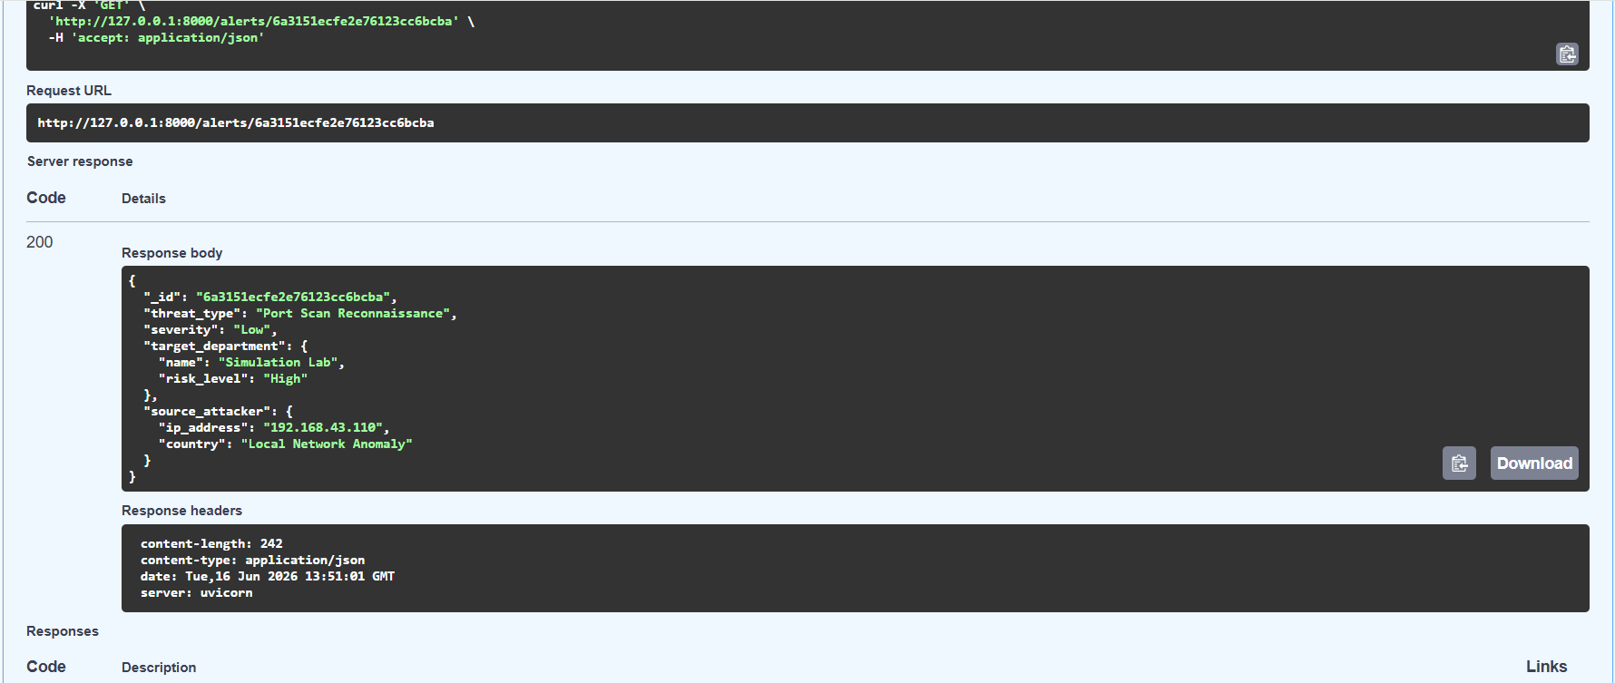
Figure 7: Live security interface tracking tracking network traces and verification requests.

Step 8: Storage Sizing and Collection Footprint Analysis
An inspection inside the local database collections verifies that the application writes tracking footprints cleanly to disk. The document structures match up seamlessly across the operational targets (alerts, attackers, departments), noting efficient page index creation and uniform, lean block allocation storage sizes.
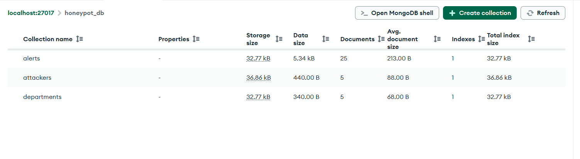
Figure 8: Administrative overview panel outlining active tables, transaction volumes, and data indices.

Step 9: Core Application Startup Log & Route Trace Monitoring
The backend terminal lifecycle log shows a clean application launch. It details active connections and records systematic route requests. The trace successfully tracks system processes through various response loops—from structural mismatches straight through to active 200 OK telemetry returns.
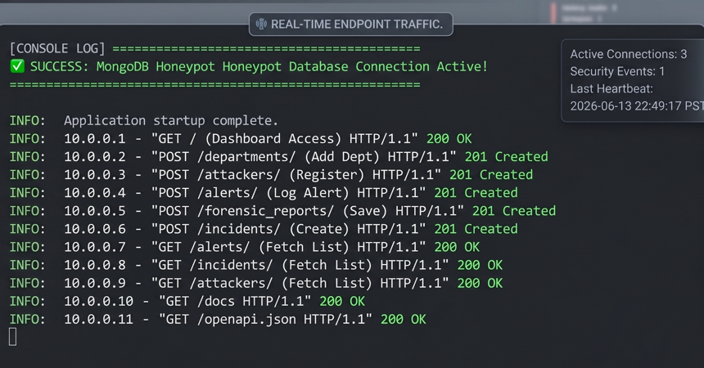
Figure 9: Service log tracking operational lifecycles, route traces, and socket returns.

